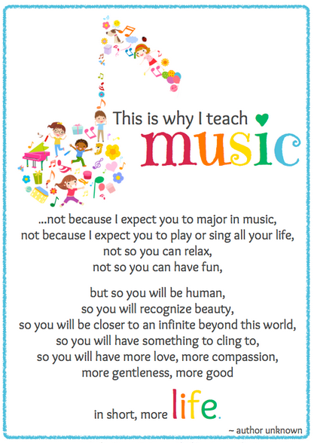

**HOLLAND WOODS**

**MIDDLE SCHOOL**

**BAND**

***Revised for 2017-2018***

Mrs. Angela Larner, Director

* Bachelor of Music Education, Graceland College, 199
* Master of Music Education, Michigan State University, 2003
* Member of the *National Association for Music Education*
* Teacher in PHASD since 2000

**Contact or Follow Mrs. Larner:**

810-984-6548 (HWMS Phone)

[alarner@phasd.us](mailto:alarner@phasd.us)

Facebook: Holland Woods Band

Band website: www.hollandwoodsband.weebly.com

**Table of Contents for Warrior Band Handbook**

1. Contact and Information Access….. ………………………………....Cover Page and 3
2. National Standards of Music Education…………………………………………..………...4
3. MSBOA (Michigan School Band & Orchestra Association)……………………….…7
4. Rules for Band Rehearsals.......................................................………….……..8-9
5. Band Class Procedures………………………………………………………………………....9-11
6. Fire Drill, Tornado Drill, Lockdown Drill………………………………………….………..12
7. 6th Grade Band (General Information) and REMINDERS for 7th/8th Grade ………………………………………………………………………………………………………......13-15
8. Materials Needed for Band…………………………………………………………………....15-16
9. Instruments………………………………………………………………………………………...16-17
10. HWMS Music……………………………………………………………………………………….....18
11. Concert/Performance Attendance …………………………………………...…..19-20
12. Grading System ………………………………………………………...…………………..21-23
13. Make-Up Work/Extra Credit/Concert Uniform………………………….....…....24-25
14. Things Parents Can Do to Support Their Child in Band…………………….……..25
15. How to Practice (For Students) …………………………………….…………………….26
16. Warrior Citizenship ………………………………..……………………………………..….27
17. Fund Raising……………………………………………………………………………….…..….28
18. Advocacy and other Information………………………………………………………..29
19. Parent/Guardian Receipt of Understanding

(Please tear out and return for 1st marking period student extra credit)..........................................................................................................30

**CONTACT AND INFORMATION ACCESS**

Welcome! If you are a new member of our band or a returning member, I would like to provide you with as much information as possible as we progress through the year together. I feel the more we communicate, the greater our successes will be. Parents, please feel free to contact me with any questions or concerns you may have. Students, if you have questions, need help, or have some issues going on, please come talk to me.

**There are a variety of ways in which you may receive and/or have access to communications regarding the band program at Holland Woods Middle School:**

**Email:** [alarner@phasd.us](mailto:alarner@phasd.us)

**Skyward:** Communication via PHASD; access to your child’s classroom grades and other information

**Facebook:** Holland Woods Band (request to join) and PHS-Holland Woods Page

**Website**: [www.hollandwoodsband.weebly.com](http://www.hollandwoodsband.weebly.com)

**Remind**: text : 81010 message:@hwbandph

**Memos/Notes sent home:** Often used for performance reminders and fundraising information. I keep extras at school for students to take.

**School Phone:** 810-984-6548 ext. 2353 and leave a message. Mrs. Larner will work to return your call within 24 hours or less.

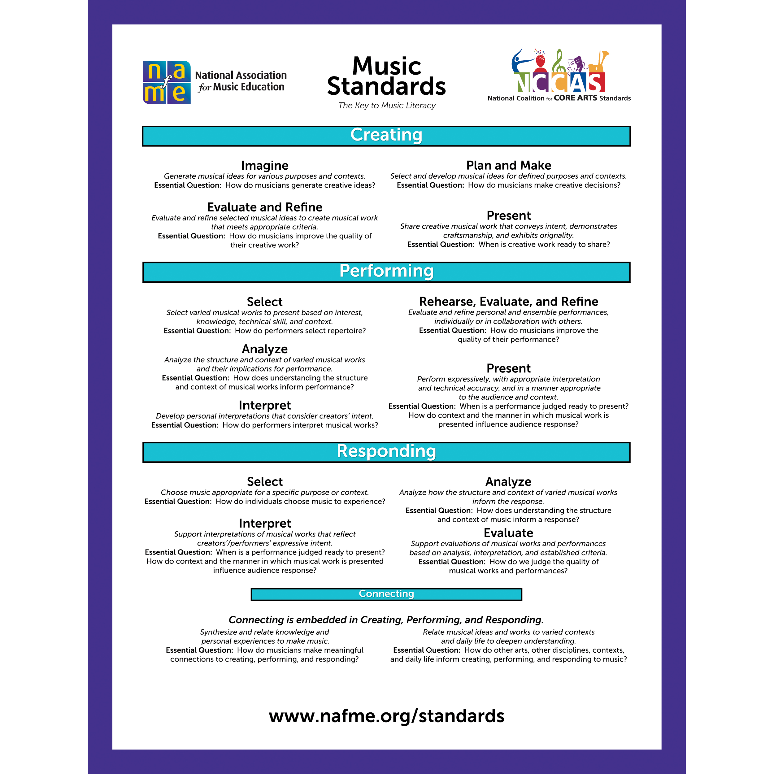

**Things to Consider...Benefits to Being in Band Beyond the FUN!**

* Researchers have found a correlation between three or more years of instrumental music training and enhanced auditory discrimination, fine motor skills, vocabulary, and nonverbal reasoning.

[Forgeard, M., Winner, E., Norton, A., & Schlaug, G. (2008). Practicing a musical instrument in childhood is associated with enhanced verbal ability and nonverbal reasoning. *PloS One, 3*(10), e3566.](http://www.plosone.org/article/info%3Adoi%2F10.1371%2Fjournal.pone.0003566)

* Students who participate in music groups score significantly higher than their peers on measures of social capital including talking more with parents and teachers.

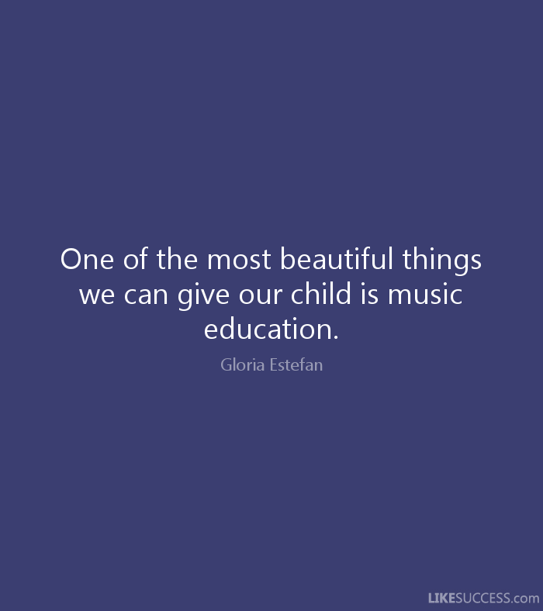[Broh, B. A. (2002). Linking extracurricular programming to academic achievement: Who benefits and why? *Sociology of Education, 75*(1), 69-95.](http://www.jstor.org/discover/10.2307/3090254?uid=3739936&uid=2&uid=4&uid=3739256&sid=21101569367673)





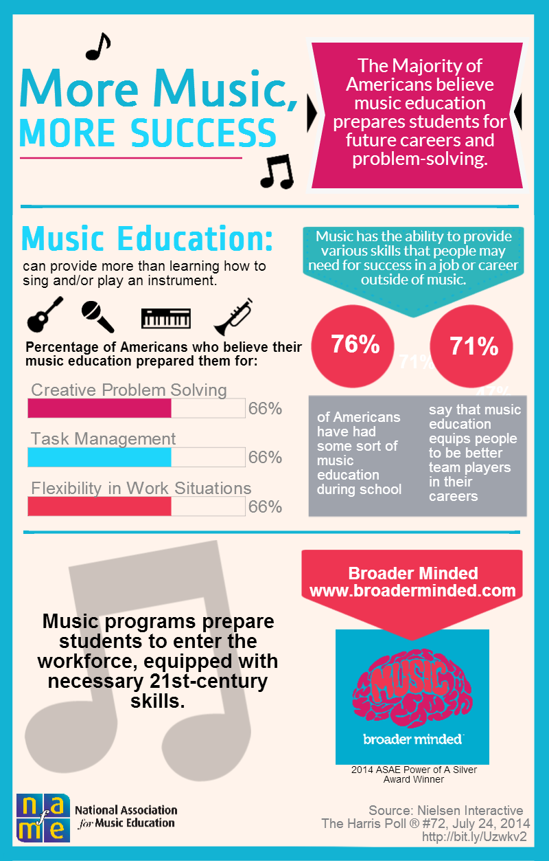

**MSBOA (Michigan School Band & Orchestra Association)**

What is it? A membership including band and orchestra teachers dedicated to providing students intellectual and creative experiences expressed through emotional and artistic communication.

**MSBOA Events for Holland Woods Middle School Bands (7th /8th):**

* **Honors Band (Voluntary)**. The director nominates 7th and 8th grade band members who demonstrate strong playing skills, a positive attitude toward the organization, and a commitment and responsibility towards the organization. Two rehearsals and a concert occur in January. An opportunity for advanced players in the ensemble to play challenging literature with other advanced players.
* **Solo & Ensemble Festival (Voluntary)**. An opportunity for 7th and 8th grade students to participate in an individual event (solo with piano accompaniment) or a group event (duet). Music is individually prepared and performed for an adjudicator (judge). This judge is a band teacher from another part of Michigan, who specializes on that instrument. Your band director provides guidance on music and rehearsals. Students receiving an “I” (A) or “II” (B) division rating receive medals at the festival.

**I HAVE A CHOICE**

**To CHOOSE means I am responsible for my choice;**

**To CHOOSE means that I am accountable for MY CHOICES;**

**To CHOOSE means that I have control over what I do;**

**To CHOOSE means that I accept the consequences of my choice-if it**

**Succeeds, praise me; if it fails, blame me**

**--Harry Wong**

**RULES FOR BAND**

**Students making the CHOICE to NOT adhere to class rules or follow classroom procedures will receive consequences for each instance (continued or varied) (i.e. Impact on Daily Participation Grade, School Citizenship Considerations, Reminders, Lunch Detentions, Seat Changes, Alternate Activities, Office Referrals as needed, etc.**

**\*\*\*\*\*\*\*\*\*\*\*\*\*\*\*\*\*\*\*\*\*\*\*\*\*\*\*\*\*\*\*\*\*\*\*\*\*\*\*\*\*\*\*\*\*\*\*\*\*\*\*\*\*\*\*\*\*\*\*\*\*\*\*\***

1. ***Be on time! Be early****!* If you are not in your assigned seat when class time begins you are tardy. **Tardies logged into Skyward impacts “Daily Participation Grade”**
2. ***Enter the band room SILENTLY.*** Do-Now’s will be on the table near the door of the room every day. Students who choose not to enter silently will be asked to leave the room and enter again appropriately. Work on, complete, and wait silently during Do-Now work-time. **–Impacts “Daily Participation Grade.” (Do Now’s also receive a daily grade entered at the end of week.**
3. ***Have all materials EVERY DAY***. (Instrument, music, reeds (if applicable), band book, pencil on the music stand, required handouts, care/maintenance materials, and school agenda/planner).—**Impacts “Daily Participation Grade (per item).” Three times without same/similar item results in lunch detention the next day.**
4. ***Following the daily ‘Do-Now,’ move swiftly to assemble your instrument and music***. Check the board for what we’re doing. Get everything in order before I begin class (Instrument is assembled, stand is in place, pencil is on your stand, and all music and warm-ups are on the stand). Make sure to grease/oil your instrument before we begin rehearsal.—**Impacts “Daily Participation Grade.”**
5. ***No talking and/or behavior disruptions during rehearsals and/or instruction time. Raise your hand to contribute answers or comments or to ask to leave your seat***. Rehearsal time is NOT social time.**—Impacts “Daily Participation Grade.”**
6. ***No gum, food, candy, flavored water, juice, pops in band***. Clear water only. Bring a ‘clear’ water bottle to class if you like. Food and sugar particles end up growing in your instrument—this is bad for you and your instrument. Students will be asked to deposit non-water items in trash. **–Impacts ‘Daily Participation Grade” and *three times bringing food/candy/non-water=lunch detention****.*
7. ***No cell phones, iPod, or any other technology are to be out in band***.**—Impacts “Daily Participation Grade’ and three and** It **will be confiscated and turned into the office at the ‘end of the day.’ After 2:15pm.**
8. ***Keep your hands, feet, and objects to yourself***. Also: No handling anyone else’s things/go into their storage areas.**-Impacts *“Daily Participation Grade. “Potential office referrals and seating/storage changes.***
9. ***Any special request hallway pass (bathroom, office, locker, etc*.) *may or may not be granted****.* School administration advises us to keep students in our classrooms as much as possible*.* You must have your own planner/agenda. Also must sign the hallway log. Use the time allotted between classes to use the bathroom. –**Impact: forms filed and turned into office: “Daily participation Grade” for students**
10. ***Instruments GO HOME every day for daily practice.*** *Not to be left (Participation Grade effected) in locker, another classroom, and office or band room. Practice Daily at home. Work hard.* ***Do your best. No excuses!!!***

**Band Class/Room Procedures**

*To be discussed, practiced, and reviewed as necessary*

1. **Participation in class—follows directions the first time; Listen; respond appropriately; participate fully.**
2. **Instrument Care**—clean instrument every day, every time you play. Oil/Grease before class and before playing at home. Do not leave reeds on mouthpieces. Regular checks for having and using materials will occur at the discretion of Mrs. Larner.
3. **Entering Room—Students will enter the room quietly. Students not entering appropriately will be asked to leave the room and re-enter in the expected manner. Upon entering room, students are to take out their pencil and QUIETLY complete their “Do-Now,” unless instructed to do otherwise**.
4. **Prepping for rehearsal**-- After “Do-Now” students will quickly get their instruments, stand, and music ready (***read the board for the day’s agenda***). Pencil on every stand.
5. **If your instrument is NOT WORKING—see Mrs. Larner before school/after school, before class/after class—do not interrupt class for me to fix or look at it. “Finger,” count, sing (participate) during class…NEVER just sit there. There’s always a way to participate.**
6. **If you do not have a reed or other needed materials—**ASK MRS. LARNER. Pay back as soon as you can. A list of owes will be kept. Notices will be sent to the office and home regarding payment for loaned materials.
7. **End of period dismissal—students dismissed by quiet, neat, ready, rows/sections/individuals. Students will receive instructions to exit to the outside of their rows as directed. Exit cards may be assigned.**
8. **Coming to attention/When teacher is talking/Students Asking Questions**—immediately get quiet and respond appropriately. *Cue for attention: Raised hand. Students are to immediately raise their hand and become silent.*
9. **If student is absent—see teacher for any missed work, quizzes.** Do-Now’s are a daily grade.
10. **If teacher is absent**—any poor reports will be followed up with consequences. Classwork. Individual detentions if students work hard to be noticed for poor behavior. Class should run the same as if Mrs. Lerner were there.
11. **Drills—it is Mrs. Larner’s duty to keep you safe in an emergency. Failure to follow band class drill procedures will result in negative consequences.** All students are expected cooperate silently during all drills.
12. **Instrument Assembling/Disassembling**—take your time and do it right. Your instruments, whether old or new, cost $$$$ and time to get fixed. Be respectful of that.
13. **Caring for music/band book**. Music received is SCHOOL PROPERTY. Music is to be stored flat in provided band folder or another folder. Music is not to be folded, crumpled, etc. All music should have student’s first/last name written in pencil in the top corner. All measures should be numbered from #1-end of music for readiness/preparedness during rehearsal.
14. **Writing in Books/On Music.** Students will be asked to write many things on their music/in their book. Examples: counting, dynamics, phrasing, tonguing, balance, and more. **Students SHOULD NOT WRITE IN NOTE NAMES**. A pencil should always, always, always, be on your stand/available.
15. **Passing in Papers—Unless Mrs. Larner (or guest teacher) is standing there asking for it to be handed in directly to them, all work goes in ‘turn-in-box.’** Turn-in drawer, labeled with each hour/grade is located near the back of room.
16. **Receiving Work Back**—Students will receive their work back in their personal mailboxes in the band room (HWMS). Students are advised to hold on to all their work.
17. **Moving about the room—raise your hand/ask to leave your seat.**
18. **Leaving the room**—students must get permission and sign out when leaving room and sign in when returning to room. If you leaving for the day make sure you have your instrument, music and anything else you may need to go home.
19. **Keep the room clean—we have several garbage cans in the band room. Use them. At the end of each class, students will be held responsible for cleaning up the floor if there is garbage. In addition, all stands may need to be racked on the correct carts and chairs straightened for next class.**
20. **Instruments**. Whether it is school-owned or privately, if student is not taking care of it, student participation may be put on hold until student calls/informs parent. Instruments must be greased and oiled, cleaned, handled carefully, etc. Mrs. Larner will hold random checks and/or graded assessments for having materials daily and for correct use of them (graded). Not having materials daily affects students’ ‘participation grade’ and actual participation in band that day.
21. **Dropping off/collecting instruments.**

* **ONLY BAND MEMBERS (WITH INSTRUMENTS TO DROP OFF)** are allowed in the hallways to directly drop off their instrument before the entry bell. Do not bring non-band students to walk with you. Mrs. Larner will complete behavior forms regarding students in the hall that are not allowed.
* **If you leave early from school, please come and get your instrument.** Enter the room quietly, grab your things, and exit without causing a distraction or disturbance to the instruction/rehearsal going on.
* **If you get to school late, come and drop off your instrument without** being a disturbance to my class that is in session.
* **Instruments are to go home DAILY. Instruments are to be practiced DAILY. Mrs. Larner tracks students leaving their instruments in the band room. Part of Participation Grade.**

1. **Behavior and Completion of Assessments**.

* **In band, there will be a variety of assessments, both formal and informal.** Students will participate in written assessments and performance assessments. Students will receive specific directions for each assessment, but in general, students are expected to be quiet and respectful at all times, whether students are playing their assessments, or completing a writing-based assessment. **All students are expected to complete all assessments as directed. Band is primarily a PERFORMANCE BASED class. Performing on instruments alone and with others will happen EVERY DAY in all grade levels bands.**
* **Retests/Retakes**. Students may retake **ANY** of their assessments. However, retakes will not occur during class time. Students wishing to retake any assessment must sign-up in advance for an after-school time (there will be one day designated for retakes). Retests/retakes will only happen on the designated retest/retake day. **All/any retests/retakes must be completed by the end of each marking period.** Students may sign up each week for retakes if they choose to until they are satisfied with their grade

|  |
| --- |
|  |

**DRILLS**

* **Fire Drills—Band Room Holland Woods MS**
  + We set our instruments down as carefully as possible and exit quickly and QUIETLY by row out back door towards the track. Because our classes are so large we will walk out to a given point and create a circle so that the teacher can keep track of all students and ensure their safety.
  + THERE IS ABSOLUTELY NO TALKING. These drills are our chance to practice for an emergency. Mrs. Larner is in charge of many, many students. Consequences for inappropriate/unsafe behavior will follow directly for student/class.
* **Tornado Drill—Band Room Holland Woods MS**
  + Those with small instruments, carry to spot told…locker/cage area of band room.
  + Other classes will be coming in too, into main room.
  + WE SIT QUIETLY, regardless what any of the other classes may or may not be doing.
  + I will not tolerate any talking or behavioral antics or pure distractions during drills. These drills are our chance to practice for an emergency. I take them seriously so that I can keep you safe as possible. Consequences for behavior will follow directly for any student who cannot control themselves during the drill. If the class misbehaves, the class will face consequences.
* **Lockdown Drill-Band Room Holland Woods MS**
  + Outside threat. Teacher locks door.
    - We remain in our seats, but don’t play, and keep it very quiet—whisper soft.
  + Inside threat. Teacher locks door. Lights out.
    - We take our instruments, books, purses, pencils; ANYTHING that looks like anyone was in the room. We sit SILENT on the floor in the corner of the room, out of sight.

**6th Grade Band Information and Reminders for all Band Members**

*Starting middle school can be daunting enough, and then adding something really new, like band, can bring up many questions, but I will work very hard to make sure my students know what they should be doing, how to do it, what to expect, and to enjoy the experience. ☺*

* **6th Grade Band: is a full year commitment.** At the end of 6th grade, students will be asked whether they wish to continue on into 7th grade band. In 7th and 8th grade band, there are many more opportunities for performance and growth (see the event schedule). Thinking ahead to play in high school it all begins in the Warrior Band 6th grade band.
* **Instrument Fitting**—the Port Huron Music Center visited most schools in the PHASD in the spring of last year (end of 5th grade). Students got to try various instruments to find what instrument(s) they would most likely find the most success with. There will be a wrap-up fitting during the school to **finalize** instrumentation so that instruction can begin ASAP. **There are no boy or girl instruments.** **If a student has the aptitude and the desire that is what instrument he or she will be successful on.**  Having a child play an instrument because the family “has” one may not be in the best interest of the child. Every child is different: facial structure, coordination, buzzing ability, desire and more. Each instrument is unique. As are all of my students. If a child is to find success and enjoy being in the band, he/she needs to begin on an instrument that they have initial abilities on and that they want to play.
* ***Switching Instruments****—***NOT ALLOWED** *once the fall fitting (when school starts) has taken place.* **A student’s best chance for success is to stick to the same instrument. Learning any instrument (or skill) takes practice. To become good and enjoy playing that instrument takes practice.** *Any exceptions made may/will be at the discretion of Mrs. Larner and special needs of a child.*
  + **It is very, VERY important that students start on an instrument they like and could make first sounds on at the “fitting.” It is also crucial that students practice every day and give their best effort. There will be ups and downs for EVERY child in the band. The more effort and practice a child puts into learning an instrument and developing their skills is directly related to how successful he/she will become on the instrument.**
* **Practicing**. Daily homework**. Mandatory and necessary if students want to succeed in class.** Students will be given specific directions as to what they are to work on. Students should practice a *minimum* of 25 minutes 6 days a week to see adequate progress. Students work on will be expected to keep up practicing over holidays as s will be expected to keep up practicing over holidays as well. Goal time is 30-45 minutes of quality hard work time. Instruments are to go home daily, weekends, and over breaks/holidays. Practice should include warm-ups, exercise from book and sheet music.
* **Concerts. CONCERTS ARE MANDATORY. All students are expected to perform at every concert for which their grade is assigned (See the band event calendar)**
* 6th Graders will perform at their own “Premier Concert” (late October/Early November). This is a short concert highlighting some of the beginning skills and songs the students have learned up to the day of the concert. It is only for 6th grade band students and friends and families. It is very fun and exciting for the kids. Other performances that include 6th grade is the Holiday concert, Spring Concert, Memorial Day parade. All concerts are mandatory/graded/part of the BAND PROGRAM unless marked as voluntary on the concert/event schedule.
* **Performance Assessments/Playing Quizzes**. Students in 6th, 7th and 8th grade will have a series of playing quizzes (performance assessments). Some will be graded and some will be informal. Assessment material for all band students comes directly from their band book and sheet music, and will be something we’ve been working on. Having students play individually is imperative for evaluating what the students have learned, what they can do, and what areas they and I need more attention. **Band is a performance-based class**. We play our instruments. We are always working to improve and be ready for performances.
* **Materials.** (Loss of ‘participation points’ will incur for not having needed materials ; LUNCH DETENTIONS AASIGNED for every 3rd occurrence, behavior form filled out as well with office)—If you need financial assistance with materials, please bring a note from home RIGHT AWAY. Mrs. Larner will do her best to accommodate, but purchases made may need to be paid back as available.
* **Band Book**—Essential Elements 2000 Book I, (6th and 7th grade) and Book 2 (for 7th and 8th grade) for the student’s specific instrument. **Students MUST have this book before the start of the 2nd week of school**. The majority of instruction will come from the technique book and students must be able to practice at home **EVERY DAY independently** and regularly to make progress.
* **Care Kit/Materials:**  for their instrument (specific by instrument) must always be with instrument-daily be proactive in caring for your instrument.
* **Reeds** (oboe, bassoon, clarinet, bass clarinet, alto sax, tenor sax)—**have more than one** on hand. *Broken, chipped, damaged reeds are not acceptable at all and will simply frustrate your student.*

**Materials Needed for Band**

* **All (6, 7, 8) students must have the proper CLEANING & MAINTENANCE materials to care for their instrument daily.** ***This is not an option! Students not bringing/using care materials may not be allowed to participate in rehearsals and may forfeit use of school-owned instruments.***

**\*\*\*\*\*\*\*\*\*\*\*\*\*\*\*\*\*\*\*\*\*\*\*\*\*\*\*\*\*\*\*\*\*\*\*\*\*\*\*\*\*\*\*\*\*\*\*\*\*\*\*\*\*\*\*\*\*\*\*\*\*\*\*\*\***

* + **Flutes**—cleaning rod, 2 very thin cloths preferable. Option for newer single cloth w/swab string.
  + **Clarinets/Saxophones**—cork grease, silk swab, reed case, 2 to three **Vandoren reeds** (clarinets size 2-2 ½ in 6th grade 2 ½ or 3’s for 7th and 3’s for 8th grade); Saxophones (2 or 2 ½ for 6th grade, 3’s for 7th/8th grade), mouthpiece brush, cleaning snake (sax, for cleaning neck)
  + **Oboes/Bassoons**—cleaning swab or snake, 1 to 2 reeds (6th grade ‘soft’; 7th/8th ‘medium soft’), reed case, cork grease, small plastic cup to soak reed DAILY.
  + **Trumpets/Baritones/Tuba/Trombone**—valve oil (not trombone unless you have an F-attachment rotary valve style), slide grease, slide cream, cleaning snake, polish cloth, mouthpiece brush
    - Trombones also: small spraying water bottle.
  + **French Horn**—slide grease, ROTARY valve oil, mouthpiece brush, cleaning snake, polish cloth
* **Percussion**—1 pair of drum sticks, 1 pair of small rubber mallets, 1 pair or yarn mallets, bell kit and practice pad.
* **PENCIL on Music Stands.** Every day in class. Mrs. Larner hands out pencils fairly regularly to students as positive rewards.
* **School-Provided Planner/Agenda (6th grade)** every day in class.
* **PLEASE NOTE: Any 3rd instance of not having instrument (or something required to play instrument), music, planner, book, care materials, reeds, will result in LUNCH DETENTION. Student will make call home/work to inform their parents.**
* **Concert Uniform.** Black shoes, black socks, black pants and a white long sleeved button down shirt. **If you need assistance** in providing some of the uniform, be sure to contact Mrs. Larner in advance of the Premier Concert.

**METHOD BOOKS NEEDED DAILY AT HOME AND SCHOOL**

**Students are expected to practice daily from this book and to have it in class, on stand.** If the student does not have this book, the student will NOT be successful in this class-daily home practice is necessary for students to make progress-basic skill work. Please make sure your child has this book (and is practicing daily)

* **6th grade**: Essential Elements 2000 Book I (for specific instrument)
* **7th grade**: Essential Elements 2000 Book 2 (for specific instrument)
* *We start 7th grade reviewing 6th grade book-Keep it*
* **8th grade:** We start 8th grade reviewing 7th grade (Essential Elements 2000 Book 2)
* We will also use supplementary books. No new book purchase necessary.

**Instruments**—***School-Owned & Personal***

* **Students are to take care of their instrument daily (at home and at school):**
  + Oil and/or grease all moving parts at home and before playing in class. ☺
  + Clean (swabs/snakes required) instrument after playing in class and after playing at home. ☺
  + Do not leave reads on mouthpieces to grow nasty bacteria mold! ☹
  + Follow all directions from Mrs. Larner in order to keep your instrument in working order. If you have questions, please ask! Don’t wait until your instrument is damaged before you see me Mrs. Larner.
  + Do not play on a broken reed. Have spares. Handle carefully to avoid unnecessary damage.
* **Brands of Instruments**—***Very, very important!***
  + **Not all instrument brands are created equal!** Quality manufacturing from historically strong name-brand companies will ensure your child has greater success.
  + Instruments do NOT have to be new to be good. Used is fine, as long as you are choosing a good brand name manufacturer. Mrs. Larner will provide this list of instrument names to new 6th grade students, but it will be available to 7th and 8th Grade students upon request. **When looking to rent/purchase an instrument brand not listed, please contact Mrs. Larner to check on its reliability.**
* **What to do when your instrument is not working:**
  + Bring it to Mrs. Larner’s attention before school, before class begins, end of class.
    - **Please do not attempt to fix things on your own or have someone at home do it unless they have training in instrument repair.**
    - Mrs. Larner may ask you to leave it for her and to ‘air finger,’ or to finger the actual instrument during class but not play. YOU ARE STILL GOING TO BE PARTICIPATING and working through the mechanical part of playing your instrument and reading music. Needing reminders to participate will affect your grade.
    - *Mrs Larner will try and fix your instrument first. If Mrs. Larner is unable to fix it, you will be notified that it needs to go the Port Huron Music Center to be fixed. If you own your instrument you are responsible for the cost of repairs. You may be issued a loaner instrument if available.*
* **School-Owned Instruments**
* The school has **some** (limited) instruments for students to use free of charge. The majority of students in the band program need to provide their own instrument. The Band Program/Mrs. Larner cannot provide an instrument for every student. Students/Families in need will assist as much as possible with what is available.
* Students and parents selected to use a school-owned instrument ***must sign a contract*** agreeing to take care of it appropriately and abide by it (the contract), otherwise the student may lose the privilege of using it! **The contract must be returned right away otherwise student will not be playing on it/using it until then.** No one will be receiving a shiny, brand new instrument, but every student is responsible for keeping it in the best shape possible so that it is available for future students to use free-of-charge. **Not practicing regularly? Not bringing it home? Not cleaning and maintaining daily? It may be getting returned to Mrs. Larner until evidence of care and practice are in place. At the discretion of Mrs. Larner, Band Director.**
* **PLEASE NOTE:** Costs for any repair/maintenance/replacement of instrument (including mouthpiece, neck straps, ligatures, bocals, etc. for damage or loss beyond normal daily use if school owned instruments being used for free by students will need to be paid before student will be reissued the instrument. Any unpaid fess for broken/lost/damaged instruments and or other provided materials will be turned into main office for collection. This is also stated in the contract.
* **Please note: Moving from 8th grade band High School Band: the expectation for students continuing into the Band program is that students have their own personal instruments (flute, clarinet, alto saxophone, trumpet, oboe, and trombone). Some “special/larger instruments can be made available. Please contact Mr. Jones at PHHS or Mr. Senkmajer at PHN.**

**SHEET MUSIC—The Majority of our Curriculum**

* ***6th, 7th, and 8th Grade band students will play sheet music.***
  + 6th graders will usually begin playing sheet music prior to the Holiday Concert.

(Depends on how the class progresses as a whole –which itself depends on how hard students work at home on basic skills in their band books)

* + 7th and 8th graders will have several pieces of music in their music ‘mailbox’ before the school year begins.
* ***Students are assigned a specific part and/or number to every piece Mrs. Larner hands out.***
  + Play only the part you were assigned unless directed otherwise by Mrs. Larner.
  + No trading parts. Mrs. Larner tracks what has been assigned. All parts are important.
  + Mrs. Larner does not always hand out ‘1st parts’ to the strongest players. In order to grow, students will be challenged on all parts throughout their band experience.
  + **Put your name IN PENCIL on all of your music.**
  + **Number every measure IN PENCIL to facilitate less wasted time during rehearsals.**
  + Keep your music in your band folder—do not fold up or put in your case, etc.
  + Lost music: $4.00 per page/sheet of paper
  + **ALL “finished” music (post-concert) will be turned in** **after the concert. All music turned in will be assigned points (graded).**
  + **KEEP TRACK OF ALL MUSIC PROVIDED, KEEP IT ORGANIZED.**
  + **HAVE ALL MUSIC EVERY DAY IN BAND CLASS.**
  + **Practice every day**

**CONCERT & PERFORMANCE ATTENDANCE**

**Band is a graded class; the major exams/grades are our performances!**

* **All scheduled performances are part of the band curriculum** ***and are therefore MANDATORY (graded***)—**300 points EACH performance!**
* *The concert schedule is provided to every band student on the 1st or 2nd day of the new school year. It is also posted in the room. Students are also reminded regularly. Information is also posted on Facebook, Remind, website, handouts going home, school announcements, etc.*
* **GRADING ATTENDANCE FOR PERFORMANCES:**
  + If a concert is missed and is an EXCUSED absence**, meaning Mrs. Larner knows at least two weeks in advance of the concert date**, then the student has the opportunity to make up the performance **(by a given deadline-1 week)** for a maximum of **85% credit**.
  + If a concert is missed (and is excused) with notification of less than 1 week prior to the concert, the maximum potential credit for make-up available is 80%.
  + Last minute illnesses/emergencies, provided there is a phone call (984-6548 ext. 2353)/email ([alarner@phasd.us](mailto:alarner@phasd.us)) /written note (from parent/guardian) **the day of the concert** or the **day immediately following the concert** (from parent/guardian)—student has the opportunity to make up the performance (**by a given 1- week deadline-paperwork form will be given to student**) for a maximum potential of 80% credit.
  + Last minute illnesses/emergencies, where there is no immediate call/email/written note (from parent/guardian) but notice received within 1 week of missed concert, then the maximum potential for make-up credit drops 75% (**by a given deadline of 1 week-paperwork form will be given to student**).
  + In the possibility that a “school event” conflicts with a band event, every effort will be made to work for a compromise to both school events. Make-ups, as necessary, would be provided with a potential maximum grade of 100% potential credit.
  + **\*\*\*\*PLEASE NOTE FOR ALL POTENTIAL MAKE-UPS:** *Students completing the make-up within 1 week of signing for and receiving concert make-up paperwork will earn up to the maximum percentage as described above. A 5% drop in maximum make-up points will occur for each week beyond the deadline (signed/received by student) that the student has not completed their make-up performance. if they were eligible for partial credit to begin with. If a student chooses to not take the opportunity to make up their missed performance, they will not receive any credit.*
  + **The performance make-up will be graded** **as a performance assessment,** complete with its own rubric. Students missing a concert and who are eligible for some amount of credit will be expected to play through the selections that their band played at the missed concert. *Assessment categories for u*se *of grading will include:* notes, rhythm, dynamics, tempo, articulation/sticking and overall style. The grade will be calculated from the maximum amount of points allotted.
  + **If a concert unexcused, there is no opportunity for make-up. Examples may include the following:**

1. I forgot/didn’t know we had a concert.
2. I did not tell my parents/guardian ahead of time.
3. I did not have a ride.
4. I was grounded/suspended/expelled.
5. I was not at home.
6. I was at a NON-SCHOOL-RELATED activity that I did not tell my director about in advance of my performance.
7. I left my instrument/music/uniform in the band room/my locker at school.
8. I did not give my parent/guardian the concert schedule, concert reminders, etc. beforehand.
9. No communication to director from parent/guardian within the “excused” window of opportunity.

* **IMPORTANT—**Please note: If there is an illness or last minute emergency, Mrs. Larner MUST BE NOTIFIED. A phone call 984-6548 ext. 2353 with voicemail and/or directions for the office to alert Mrs. Larner or an email: [alarner@phasd.us](mailto:alarner@phasd.us); or a written note from the student’s parents or guardian the following day.
* **An absence from school or band class on the day of a performance is not excused w/out notification.**

***We need every student to participate. “Our” success depends on “all” of us. ☺***

***No one “sits on the bench” in band. Every note, every rhythm, every student…we rely on each other from start to finish.***

**Being a part of the Warrior Band requires you to be the committed, to do your best in and out of the classroom and for you to be responsible to both you and the rest of your band by fully participating in all that we do!**

**GRADING SYSTEM-BAND**

A = Excellent, B= Good, C= Average, D=Poor, E= Failure

**Student Evaluation:**

* ***Concerts/Performances***—300 points possible (late, not in uniform, behavior, etc. will be reflected in grade):
  + Incorrect uniform = -25 points (if you need financial assistance with part of the uniform, Mrs. Larner must be informed well in advanced. (**Black pants, black shoes, black socks, white long-sleeved button down dress shirt.** Shirts are tucked in.
  + Late = -25 points
  + Inappropriate Stage Deportment (talking on stage, chewing gum, causing distractions, etc.) = -25 points per instance
  + Behavior/discipline concerns pre/during/post-concert= -25 (possible detentions, if behavior warrants it)
* ***Playing Quizzes/Performance Assessments***
  + 100 points possible
  + *All band members will have several performance assessments per marking period. Assessments happen during class for all students.*
  + *Most assessments are scheduled assigned “pop” quizzes/assessments on material they should have and/or be practicing at home.*
  + *Students are expected to practice daily. Material for assessments will come from the “Essential Elements” skill book, music being worked on for performances, warm-up/chorale/supplemental skill builders, tuning/balancing skill builders. Any and all material used for instruction and/or reinforcement would be applicable.*
  + ***Students have the opportunity to retake and performance assessments that they CHOOSE to within a marking period for grades.***
    - Retakes/Retests: Must sign up in advance for a designated day (at Mrs. Larner’s discretion) after school. Students are able to retake/retest as many times as they like to get the grade they are satisfied with, up until the end of the marking period.
* ***Written Quizzes/Assessments*** = 50 to 100 points possible
* ***Assignments*** = 25-50 points
* ***Do Now’s*** = 50 points per week (10 points per school day)
  + Each day of the week will incorporate a different-style Do-Now.
  + Do-Now’s are silent ‘bell work’ for each class.
  + Students must complete Do-Now’s for credit.
    - Students may be asked to redo, etc. if concept not completed satisfactorily. Absent students must request make-up work from Mrs. Larner
* ***Pretests/Posttests*** = NOT GRADED. Intent: to show growth from beginning of year to end of year regarding specific material. (No retakes on pre/posttests). Data collected and saved.
  + Written Pre-Test Based on Curriculum (within 1st/2nd week of school for 6th, 7th and 8th grade band members)
  + Written ABC Reading/Writing Pre-test (tentative completion date within the 1st month of school for 6th, 7th, and 8th grade band members
  + All posttest will be completed as determined by due dates for data set by school administrator.

**Weekly Student Participation**

* **50 points per week**.

**Positive Indicators (EXPECTATIONS) for Daily Class Activities:**

* Has required material for rehearsal (instrument& items needed for instruments, all music, band book, chorale/scale/warm-up sheets, pencils on music stand**,** handouts, staff paper and care material)
* Is seated in assigned seat (on time) by the time class is set to begin-working on Do Now).
* Is seated (percussion standing at appropriate instrument) and ready to begin when conductor signals.
* Follows instructions the FIRST time and beyond
* Consistently and fully participates in classroom discussions, activities and rehearsals.
* Shows a POSITIVE ATTITUDE toward teacher and peers and rehearsal /work process.
* Always demonstrates GOOD REHEARSAL DISCIPLNE &TECHNIQUE.
* Works well with minimal supervision.
* Always shows RESPECT for school equipment and property.
* Consistently takes instrument HOME TO PRACTICE in order to CONTRIBUTE to the next day’s rehearsal (including weekends/holidays/breaks)

**Excellent: Grade Range A (0 flagged indicators for the week)**

**Good: Grade Range B (1-2 flagged indicators and/or TOTAL instances represented during the course of one week):**

**Average: Grade Range C (3-4 flagged indicators and/or instances represented during the course of one week):**

**Poor: Grade Range D (5-6 indicators and/or instances represented during the course of one week):**

**Failing: Grade Range (7 or more indicators and/or instances represented during the course of one week):**

\***Rehearsal Discipline includes:**

*Silent, focused, ready

*When teacher working with small section or single student, choose:

*Silent fingering through a challenging passage, silent counting, finger your part at the same measure teacher is working on with small group, etc. as expected by director.

*Marking music when needed; pencil on stand

*Best effort

\***Rehearsal Techniques includes:**

*Sitting tall, front of chair (all except tuba)

*Both feet flat on floor, tapping one foot with steady pulse

*Eye contact

*Full breaths

*Participating….best effort…. Working to apply all learned/discussed and/or rehearsed musical concepts and skills.

**Extra Credit:**

If students are doing what they need to do ***(attending performances, practicing at home, turning in logs, taking advantage of retake/retest opportunities, appropriately participating—see previous description of ‘participation’)***, there should be little if any need for extra credit in band. Therefore, there are only two means of working for extra points are available:

* **Attending non-Holland Woods MS Concerts/Musical Events** or a Central MS concert you are not scheduled to perform at (example: 7th grader attending the 6th grade Premier concert, etc.) and bringing the program to Mrs. Larner the next day. **‘Maximum** **Possible’ Points: +25**

**\*\*\*Please note:** If a student has an “excused” concert to make up, the student must do the concert make-up (play through all performance music for Mrs. Larner outside of the school day) **before any other (see above) extra credit will be accepted.**

**************************************************************************************************************

**MAKE-UP WORK**

* If a student is absent, he/she must see Mrs. Larner for missed work:
  + **Do-Now’s**: Depending on the day missed, an alternate Do-Now will be provided.
  + **Playing Quizzes/Tests**: Student will complete quiz/test upon their return to school. Material to cover is posted in advance and material is/has been reviewed in class.
  + **Pop Quizzes**: As needed, sections may be assigned a quiz for the next day, and/or without notice. The more prepared student is for class, the less likely they will have “pop quizzes.” Material comes from book exercises, warm-ups, chorales, and/or sheet music being worked on.
  + **Worksheets**: Students will receive and will need to turn in the next day.
  + **Concerts/Performances**: Please see section regarding “Concert/Performance Attendance” for detailed information. **CONCERTS ARE MANDATORY**

**CONCERT UNIFORM-ALL BAND MEMBERS**

* Black pants (may be black dress pants or fully black jeans)
* Black shoes (no white laces or markings to show)
* Black socks
* White, Long-Sleeved Button Down Dress Shirt (tucked in)

**If you/your family needs assistance in getting some part of the uniform, please let Mrs. Larner know in ADVANCE. Not the day of or the day before the concert.**

**THINGS PARENTS CAN DO TO SUPPORT THEIR CHILD IN BAND**

* **Schedule a REGULAR PRACTICE TIME for your child**. 25 minutes daily (minimum). The goal should be 30-45 minutes of solid “I’m practicing to get better” time.
* Practicing does not include: assembling or disassembling instruments, taking a TV/iPod/texting break, etc.
* The focus should be your child getting better on their instrument.
* ***Encourage. Encourage. Encourage***. Learning an instrument and reading music will have its highs and lows. Learning new skills and getting good at them takes lots of practice, as well as patience and persistence.
  + **Some successes come in leaps—some in small steps**. As long as your child is practicing regularly/daily and showing improvement, things are moving in the right direction.
* **Listen**. Listen for your child to be practicing DIFFERENT things. They should practice what they enjoy, but they will also be expected to practice things they are not good at—in order to become stronger and better players.

**Parents, if you have questions or concerns or are looking for more ways to support your child as he or she learns and continues to make progress, from 6th-8th grade, please don’t hesitate to call or email me:984-6548 ext. 2353 or** [**alarner@phasd.us**](mailto:alarner@phasd.us) **I want all of my students to be successful and to enjoy being in band.**

**FOR STUDENTS—HOW TO PRACTICE. WHAT TO PRACTICE.**

If you want to be good, even great at something*,* you must practice. Rock stars, professional athletes, actors, etc. have had to practice hard to get where they are today. Signing up to be in band is no different. I want you all to be awesome*, but* how good you become depends on how much and what **you** practice at home.

**How Do I Practice? (6th, 7th, 8th Graders)**

* C:\Users\Manhart\AppData\Local\Microsoft\Windows\Temporary Internet Files\Content.IE5\YQP38ECR\MC900441896[1].wmfIt’s more than putting your instrument together and rushing through your book or songs.
  + ***Warm-up***. The warm-ups and exercises we do in band are great to work on at home. Copy what we do at the start of every hour.
  + ***Check your planner. Review the week’s assignment on the board*** **& write it in your planner.** What specifically do you and/or your section need to work on to come to class playing better tomorrow?
  + Practice your scales, lip slurs (brass), book exercises, music selections (songs)
    - ***C:\Users\Manhart\AppData\Local\Microsoft\Windows\Temporary Internet Files\Content.IE5\LU3BOH2M\MC900230795[1].wmf****Make sure you are playing the correct notes & rhythms, with correct tonguing, dynamics, and everything we talk about in class.*
    - *Play at the speed we do in class. If it’s too hard, slow down to clean it up first, then work at playing it faster but still clean.*
    - *Sit up tall at with good posture.*
    - *Use tons and tons of good air!*
    - ***C:\Users\Manhart\AppData\Local\Microsoft\Windows\Temporary Internet Files\Content.IE5\D3K74N5I\MC900446388[1].wmf****Keep your lips firm! Use your tongue to articulate!*
    - ***C:\Users\Manhart\AppData\Local\Microsoft\Windows\Temporary Internet Files\Content.IE5\LU3BOH2M\MC900230803[1].wmf****If you don’t know a fingering, take a moment to look it up in your book. If you don’t know how to play a rhythm, write in your counting’s to break it up, like we do in class.*
    - *Focus on small chunks—focus on the spots you really are NOT GOOD AT. Once you can play the small chunk, or few measures, put it back together.*

***Practice enough to make sure you know it! ☺***

***C:\Users\Manhart\AppData\Local\Microsoft\Windows\Temporary Internet Files\Content.IE5\YQP38ECR\MC900060347[1].wmfSelf –Check- Reality- Check:*** *If you can’t play it several times without error or controlled quality, you need to practice it more. Really. Be honest with yourself and work to get better: You can do it!! Set high goals and standards for yourself-hard work pays off!!!!*

**Holland Woods Middle School WARRIOR CITIZENSHIP**

* 1- ALWAYS:
  + Works toward personal best
    - *Displays exemplary attitude, enthusiastic, contributes*
  + Shows a strong work ethic
    - *Prepared for class, focused on learning, follows directions*
  + Accepts personal responsibility
    - *Maintains self-control, stays on task, seeks help when needed*
  + Positively interacts with others
    - *Displays leadership, helps others, cooperative, tolerant of others*
* 2- ALMOST ALWAYS:
  + Works toward personal best
  + Shows a strong work ethic
  + Accepts personal responsibility
  + Positively interacts with others
* 3- USUALLY:
  + Works toward personal best
  + Shows a strong work ethic
  + Accepts personal responsibility
  + Positively interacts with others
* 4- FREQUENTLY STRUGGLES WITH:
  + Working towards personal best
  + Displaying acceptable work ethic
  + Accepting personal responsibility
  + Maintaining positive interaction with others
* 5 - MOST OFTEN STRUGGLES WITH:
  + Working towards personal best
  + Displaying acceptable work ethic
  + Accepting personal responsibility
  + Maintaining positive interaction with others

**FUNDRAISING FOR THE BAND PROGRAM**

The band program at Holland Middle School provides MANY opportunities for learning and performance for students. Costs associated with, but not all-inclusive include:

*Purchase of instruments for some of our students to use free of charge while at Holland Woods; purchase of percussion equipment and hardware; purchase of replacement stands/chairs; music purchases for festivals, MSBOA Band Festival Registration fees for 7th and/or 8th grade bands; festival meals for 7th and/or 8th grade students; MSBOA room plaques and individual medals for 7th and 8th grade band students; busing for some events; additional costs in connection to concerts, festivals; reeds, mouthpieces, ligatures, care materials, neck straps, equipment for the room and student use; reward programs for our students, classroom materials and resources; uniforms; clinicians; current technology; CD’s/DVD’s relevant to supplement student learning, etc.*

In order to provide the current level of music education and resources for the students at Holland Woods Middle School, the Holland Woods Middle School Band relies heavily upon the support and generosity of parents and other members of our community.

Throughout the year, the Holland Woods Middle School Band will conduct three main fundraisers:

**Fall**: Little Caesar’s Pizza Kits

**Winter:** TBA

**Spring**: TBA

**Your support is always needed and always greatly appreciated!**

**If you would prefer to make a donation to the band program, please send your tax-deductible contribution to:**

Holland Woods Middle School Band Program

C/O Mrs. Angela Larner

1617 Holland Ave

Port Huron, MI 48060

***Benefits of a Musical Education:***

* **Improved Reading Skills** (Academic Achievement)***--***The combined results of 30 studies indicate that music instruction has a significant positive effect on reading. **Update: Applications of Research in Music Education, 2008**
* **Grit** (Inherent Benefit)**-**In a high-level performance environment, hard work and dedicated practice predicts success far more than innate ability. Music performance offers opportunities to fail. Students learn the value of persistence, and of working hard for an uncertain outcome.
* **Collaboration (21st Century Skill)--**Through working together to create a finished product, students learn to incorporate different approaches and to leverage individual strengths for a higher-quality outcome.
* **Communication** (21st Century Skill)--Students learn to convey ideas and emotions through musical performance; in doing so they develop a greater awareness of nuance, complexity, structure, emphasis, and theme, which can enhance verbal and written communication skills.
* **Spatial Reasoning Abilities** (Academic Achievement)--Multiple studies indicate that early music instruction is linked to significant improvements in spatial reasoning. **Neurological Research, 1999; Journal of Research in Music Education, 1998;Journal of Aesthetic Education, 2000**
* **Decision Making** (Inherent Ability)--Through both the creative and reflective learning process, students gain greater capacity to question, interpret, and influence their own lives.

***Find more benefits of music at: http://broaderminded.com/

**MUSIC EDUCATION ADVOCACY**

School Music Matters: <http://schoolmusicmatters.com/>

Children’s Music Workshop: <http://www.childrensmusicworkshop.com/advocacy/toptenquotes.html>

The National Association for Music Education: <http://www.menc.org/resources/view/music-education-advocacy-central>

NAMM-sponsored Support Music: <http://www.nammfoundation.org/support-music>

* In a 2000 survey, 73 percent of respondents agree that teens who play an instrument are less likely to have discipline problems.  
  *- Americans Love Making Music – And Value Music Education More Highly Than Ever, American Music Conference, 2000.*
* Students who can perform complex rhythms can also make faster and more precise corrections in many academic and physical situations, according to the Center for Timing, Coordination, and Motor Skills  
  *- Rhythm seen as key to music’s evolutionary role in human intellectual development, Center for Timing, Coordination, and Motor Skills, 2000*.

A ten-year study indicates that students who study music achieve higher test scores, regardless of socioeconomic background.  
*- Dr. James Catterall, UCLA.*

Parent/Guardian Receipt and Understanding

Of the Holland Woods Middle School Band Handbook for the 2016-2017

* Mrs. Larner discusses the handbook page by page within the first two days of school and **each student** **(6th 7th and 8th grade will have signed stating that they have received it.** Any students registering after that point will receive the handbook (and other pertinent handouts) without detailed discussion (and will sign upon receipt of receiving).
* All students will be held accountable for the information, material, and expectations stated throughout the handbook.
* It is Mrs. Larner’s goal to be fair and consistent with each child in the band program.

*I have received and read through the Holland Woods Middle School Band Handbook and understand the expectations and policies for my child, as a member of the organization*.

Student(s) in band: first and last name(s): ____________________________________________________________________________________

Parent Signature: _________________________

Student Signature: ________________________

Parent Phone Number____________________ Email:___________________________________

Date: ______________________

Please return to Mrs. Larner for credit. Thank you very much.

**Holland Woods Middle School Band**

**2016-2017 Handbook**

**6th 7th and 8th Grade Bands**

